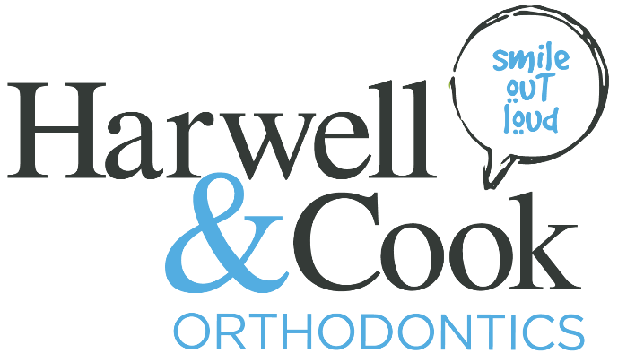

Orthodontic Assistant
Briefing:
Responsible for assisting Orthodontist in the clinical treatment of patients. Taking impressions in patients' mouths, taking X-rays, changing out wires and brackets, typing up patient charts, giving oral hygiene instructions and sterilizing instruments and equipment. To uphold the image of Smile Out Loud and maintain our high standard of excellence in the Orthodontic industry.

Key Responsibilities:
- Maintaining accurate records of patients' oral health histories and treatment progress.
- Ensuring that all orthodontic instruments and equipment are properly sterilized before each use.
- Keeping patients’ mouths dry during orthodontic procedures by using a suction hose as needed.
- Taking intraoral X-rays of patients’ mouths.
- Taking photographs of patients’ teeth to aid the Orthodontist in developing treatment plans and to document patient progress.
- Taking dental impression and scans of patients’ teeth for the fabrication of customized mouthguards and retainers.
- Removing and replacing wires, coil springs, and elastic bands.
- Educating patients on proper oral hygiene practices, elastic wear, and braces aftercare
- Sound knowledge of various orthodontic procedures and practices.
- Anticipate and assist your co-worker’s needs
- Perform general maintenance duties related to machines and equipment used by clinical staff
- Packing and unpacking supplies/equipment for travel
- Performs other duties as requested or required by management

Key Requirements:
- High School Diploma or equivalent.
- Must be 18 years of age or older.
- Customer Service attitude and focus
- Aptitude and interest orthodontic care
- Strong interpersonal skills to maintain effective rapport with patients and fellow staff

- Perform all other physical aspects of the job including bending, squatting, lifting, climbing, and walking
- Manual dexterity in assisting
- Working knowledge of orthodontic terminology
- Highly organized and be able to muli-task with the understanding of priorities
- Ability to handle sensitive and confidential information
- Knowledge of Ortho2 Edge Practice Management Software
- Knowledge of Microsoft Office (word, excel, etc.)
- Registered dental assistant credentials.
- CPR certification.
- Ability to function as a team member and get along with others

